Scheduling Simulator

Jonathan Bernal
Computer Science Engineering MS program
Santa Clara University
Santa Clara, CA
jjbernal@scu.edu

Jerome Solomon
Computer Science Engineering Ph.D program
Santa Clara University
Santa Clara, CA
gsolomon@scu.edu

Abstract—It is often difficult, if not impossible, to predict the performance of a given scheduling algorithm without actually running it. Scheduling algorithms are often highly complicated and can take a large number of parameterizations, each of which can have significant effects on system performance. In this paper, we explore various scheduling algorithms and analyze their performance.
Keywords—scheduling, simulator, performance

Intro:

One of the main functions of an operating system is to “feed” the CPU, ie. to keep the CPU occupied with work as long as there is work to be done. More specifically, one of the fundamental duties of an operating system (OS) that supports multitasking/multiprocessing is to determine which process or processes need to be run next and when (and in the case of multiprocessing, where) they execute. The OS scheduler creates an ordering between processes which ultimately determines how long each process takes from start to finish (turnaround time), how long each process will wait to receive cpu time (waiting time), how long each process will take to respond (response time), and the expected amount of work done in a time unit (throughput). Different applications may have different performance requirements. A classic example is real-time applications that may want to have a low response time to provide a low-latency interactive experience to a user.
An issue with some schedulers is the need for parameterization in some form or another in order to run effectively, with different parameters sometimes interacting with each other in unpredictable ways. As the number of parameters increase, so do the degrees of freedom of the algorithms behavior. It is difficult to know what the performance of an algorithm will be a priori because of these complex parameter interactions, but their effects can be seen macroscopically.
Because of these different performance requirements/preferences and the different workloads they may have, it is important to be able to analyze the the behavior of the scheduling algorithms under the various workloads and to be able to compare their various statistics, as well. It is the purpose of this project to provide the following:
- A method for modeling processes
- A framework that simulates the flow of processes through the various process states
- A set of algorithms that can simulate the behavior of the scheduling algorithm

Design:
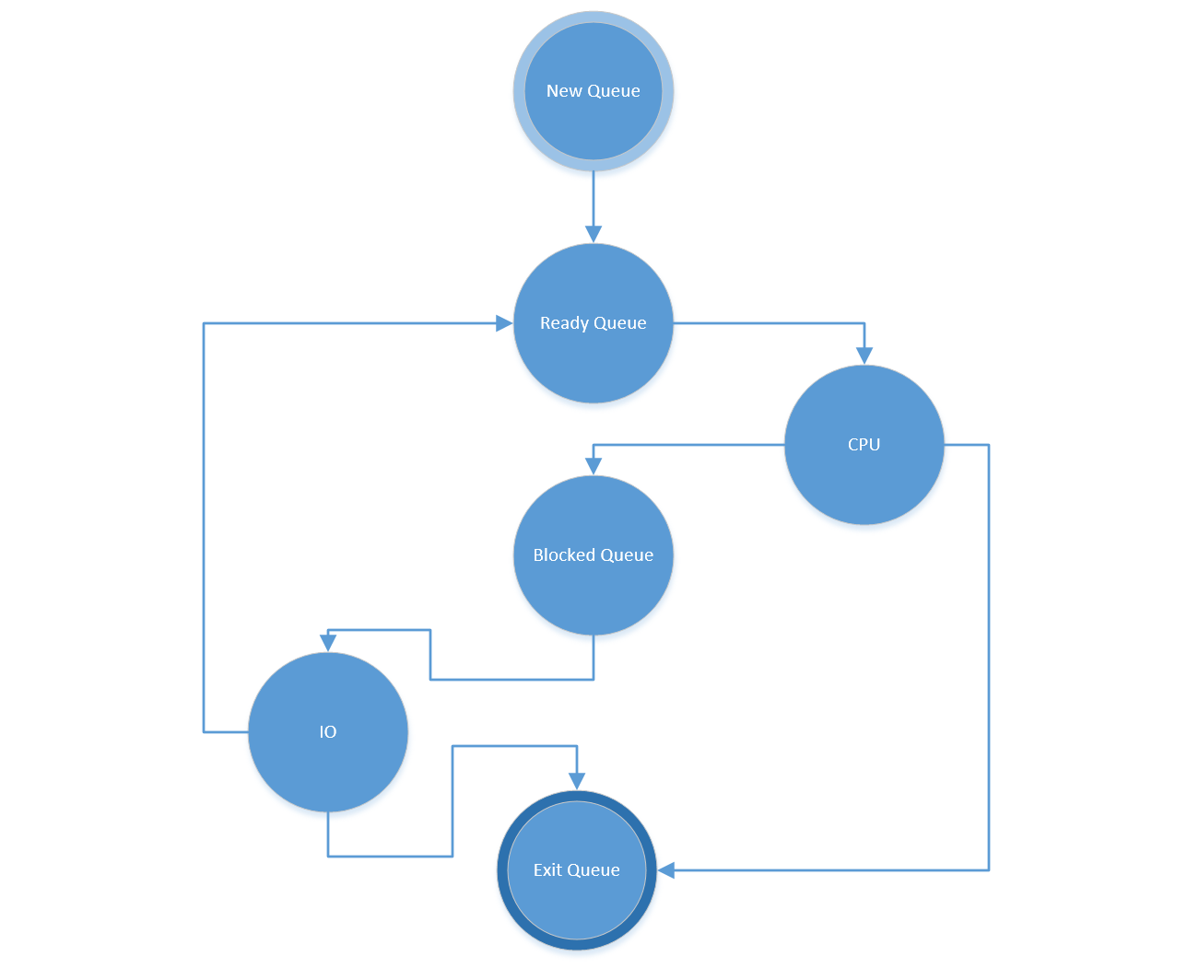
Figure 1: State diagram

Machine Design:
The machine contains the following information:
- New queue
- Ready queue
- Multi-core CPU array
- I/O
- Blocked queque
- Exit queue
- Time/clock
- Statistical variables and flags

The overall simulation tool is written using hierarchical object oriented design. There is a base “Machine “class the handles all of the basic routines using FCFS methodology of scheduling. For additional scheduling algorithms only the functions needed to process the ready queue and preempt the processes are written. So, most of the base class functions can are re-used.

The code has some intricacies to it. But, at the heart of it lies a simple routine written in psuedocode as follows:

while (machine is not empty)
process_new_queue()
process_ready_queue()
process_cpu()
process_blocked_queue()
process_io()
process_exit_queue()
time = time + 1

Due to this generalized design, each scheduling algorithm can be fully implemented within the class structure by only implementing the specific functions that are inherently different & specific to the algorithm itself.

The full code base in python is publicly available on GitHub: https://github.com/jeromesolomon/scu-coen283-os-scheduling-simulator

States in the machine are represented with data structures and variables and everything is timed using a master clock. As the clock advances forward in time 1 unit, each state is checked to see if the process in that state needs to change states or if processes in the structure require updating. If so, the machine takes the appropriate action, moving the process through the state machine to its next state or updating flags and variables inside processes. The machine continues looping through these checks and actions until everything but the exit queue is empty.

Process Design:
Processes contain the following information:
- Unique Process ID#
- Process Name
- Payload of CPU and I/O bursts
- An assigned timeslice
- A priority*
- A virtual runtime*
- A preempted flag
- Statistical variables and flags
* used by certain algorithms
The Process class also contains two ways to create processes: a statistical method that generates a process using means and standard deviations for CPU and IO burst lengths, and a direct method that builds the payload one burst at a time.

Test Harness:
A test harness was created to fully test the accuracy and implementation of the design. The test harness allows the simulation across three dimensions.

OS Workload
The test harness can run 1, 10, 50, 500, 1000 processes or more.

CPU cores
The test harness can run single core, 4 core, 8 core, 16, core, or more.

Scheduling Algorithm
The test harness runs through each scheduling algorithm for each of the dimensions listed above (cores and workload).

In addition to this, the design of the test harness allowed us to create 4 types of workloads for the simulator. We support the following types of workload bursts:
Balanced - 50% cpu and 50% IO
CPU Heavy - 90% cpu, 10% IO
IO Heavy 10% cpu, 90% IO
CPU Only 100% cpu, 0% IO

Each workload burst is given a random amount of time from 1 to 10 to simulate various types of applications.

Design Challenges

The largest design challenge we faced was trying to figure out when to sample the status of the machine to report data in to the .csv file we saved. Since the machine moved processes so fluidly from state to state it was hard to figure out when to sample. Our processes of the “process_io” routine had to be broken in to two functions in order to flow us to sample and write the state in to the middle of the procces_io() function. Processes have to be moved in to IO, processed, then sampled for their state, then checked again to figure out if the process should move to the ready-queue or preempted and moved to the io-queue. The sample of their state and recording of data to the .csv file(s) has to occur in the middle.

Algorithms:
The algorithms we chose to simulate and analyze in our project are:
- First Come First Serve (FCFS)
- Round Robin (RR)
- Shortest Job First (SJF)
- Shortest Remaining Time First (SRTF)
- Multilevel Feedback Queue (MFQ)
- Fixed Priority Preemptive Queue (FPPQ)
- Completely Fair Scheduler (CFS)

FCFS/RR:
FCFS and RR are scheduling algorithms that respect insertion time, meaning that the oldest process/processes are chosen first. In terms of implementation, they are both implemented as queues, but RR has an extra parameter in the form of the quantum. The quantum is the maximum number of time units a process can be on the cpu before it is preempted (i.e. removed from the cpu and put back into the ready queue). [1] If the quantum chosen is greater than or equal to the longest burst time for all processes, RR becomes fundamentally equivalent to the FCFS algorithm.

SJF/SRTF
SJF and SRTF are scheduling algorithms that respect cpu burst times. They both choose the “best” process to run by looking at CPU burst times, with SJF being non-preemptive and SRTF being preemptive (using a quantum). This type of scheduler is completely unimplementable because it requires knowledge about the future in order to work, but is still important from a theoretical standpoint because it always gives the optimal waiting time for any given load. Both work by choosing the “best” process to run at any given time. SJF always chooses the process with the shortest burst time first and then finishes that burst before choosing another process. SRTF always chooses the process with the shortest remaining burst time first at every time unit. [1] This means that if a process is inserted into the queue that has a shorter remaining burst time, it will immediately preempt a currently running process. A problem with SJF/SRTF is that it can result in starvation, which is when a process never gets a chance to run because other processes will always be favored more.

MLFQ:
MLFQ is a scheduling algorithm that attempts to minimize wait times as with SJF/SRTF, but in an implementable way and using a dynamic quantum and a parameter called priority. The structure consists of multiple RR structures, each of which is assigned a priority and a quantum which increases exponentially as priorities decrease. The structure always returns the first element of the highest priority RR structure when queried. Insertion of a processes requires knowledge of whether it was preempted or not during its last run. If it was preempted, the structure demotes the process to a lower priority and puts it in the appropriate queue. If the process was not preempted, the structure promotes the process instead and puts it in the appropriate queue. [1] Starvation can still occur in this model, as higher priority queues could stay full and never allow lower priority queues a chance to clear their contents. To solve this, it is possible to occasionally move all processes to the highest priority queue and allow the processes to run, thus ensuring that all the processes have a chance to run and advance their execution.

FPPQ:
FPPQ is a scheduling algorithm that respects assigned priority absolutely, meaning that it always chooses the process with the highest priority to run next and will preempt processes already on the CPU if there exists a process in the structure with a higher priority. Unlike MLFQ, FPPQ’s priorities are assigned externally and are static for the entire life of the process. In our implementation FPPQ is modeled as a minheap indexed primarily by priority number (higher numbers mean lower priority).and secondarily by process ID (always unique). FPPQ is also potentially susceptible to starvation in the same way as MLFQ in that lower priority processes may be indefinitely prevented from running by higher priority processes. The solution to this is to gradually increase the priority of processes that have been waiting so all processes eventually get to run.

CFS:
CFS is a scheduling algorithm that attempts to be as fair as possible to processes by taking into account priority, execution time, and a user-defined adjustment value called the nice value, and calculating a metric called virtual runtime. The two highest priority levels of CFS are still essentially FCFS and RR-based, respectively, to provide the best response time and wait time to real-time processes. However, any process that is not a real-time process is inserted into the main structure of CFS, which is a red-black tree which uses the process’ virtual runtime as its key (and secondarily, its process ID) and maintains a constant pointer to its minimum element. [2] The remainder of this explanation will describe the behavior of the non-real-time portion of the structure.
In practical usage, users are able to assign a “nice value” to a process when it is run, which lets the process know how long it should allow itself to defer to other processes of the same/similar priority. A high nice value indicates that the process should be willing to wait a long time whereas a low nice value indicates that the process wants to go ahead of other processes. The nice values are mapped into corresponding “nice weights” which are later used to adjust the virtual runtime of a process.
Each process has a weight that is assigned to it according to its priority. In CFS, the weights exponentially increase as priority increases, meaning that the importance of each level is a constant multiple of the importance of the level before it.
Newly added processes always get the minimum virtual runtime present in the tree, or 0 if the tree is empty. For processes that aren’t newly added (i.e. they have run at least once), the new virtual runtime is calculated by taking the old virtual runtime and incrementing it by the time the process spent on the cpu scaled by the ratio between the baseline niceness (nice_0_weight) and the weight of the process (process_weight). That is to say,

vruntime_{new} = vruntime_{old} + t_{prev_burst} *(nice_0_weight / process_weight)

In this way, as the weight of the process increases or the niceness of the process decreases, the new virtual runtime advances more slowly, whereas processes with lower weight or higher niceness value will make the virtual runtime advance more quickly. The effect of this is that processes that advance their virtual runtimes more slowly will tend to stay close to the minimum virtual runtime when reinserted into the red-black tree, and thus will be chosen to run sooner, whereas processes that advance their virtual runtimes more quickly will need to wait longer to run again.
The amount of time a process spends on the CPU can be defined as follows:

t = t₀*(w_{process}/w_{total})

where t₀ is the length of a master time slice, w_{process} is the weight of the process, w_{total} is the sum of all weights in the tree. Thus, processes always receive some amount of CPU time proportional to their weight.
Starvation is much less of a problem in the tree structure of CFS because virtual runtimes monotonically increase. Suppose a starved process has some virtual runtime v and suppose that v is the second lowest virtual runtime (there is something that must run before it). If new processes, which initialize their own virtual runtime to the minimum virtual runtime in the structure, are being added at a rate equal to or faster than they are being removed, v will starve forever. But if processes are always being added at an equal or faster rate than they are being removed, this is a much larger problem than starvation.
CFS is highly parameterized, in terms of the choice of a master timeslice as well as the nice value to weight mapping, which can take a number of parameters up to the size of the domain of the mapping (40 values in the CFS used by linux since 2007).

Design Methodology and Space Exploration

We explored and proved our design through rigorous methods. Our first goal was to simulate the four algorithms covered in Professor Elkady’s lecture and insure our results matched. For the first step to achieve this goal we rigorously traced each of the four core scheduling algorithms by hand (RR, STRF, FCFS, SPF). An example of our trace of SRTF on graph paper is below. This insured we had a solid understanding of the algorithms.

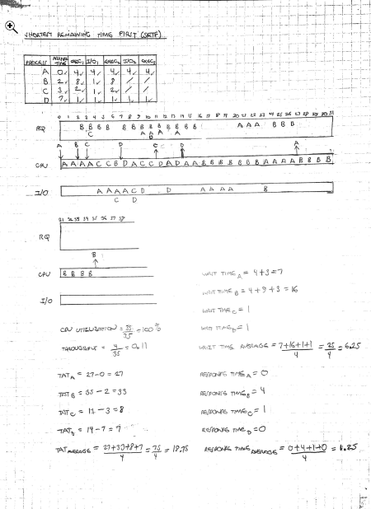
Figure 2: Testing handwork

For each iteration in our design and implementation we converged to get our results to match. Our final results are shown in table 1 and figure 3. In addition to a single core, our simulator is capable of running the same lecture examples with multiple cores. So, we ran the lecture example with 1, 2, and 4 core simulations yielding the following results. This proved our methodology and design was solid.

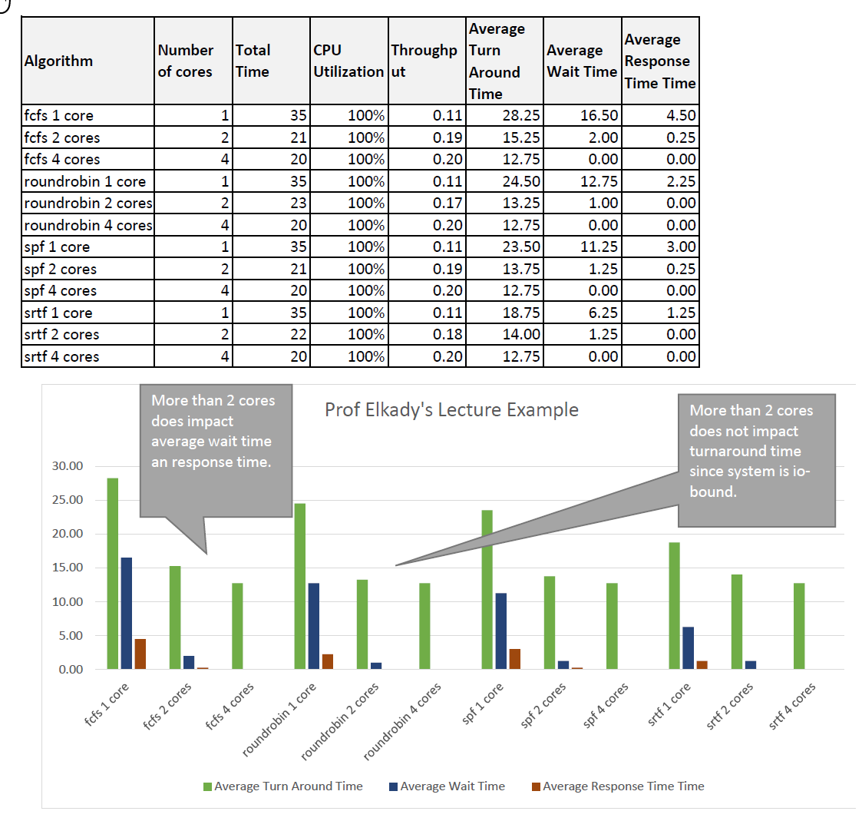
Table 1 and Figure 3: Lecture example

Results:

Test description:
In order to test each of the various schedulers, four types of workloads are randomly generated (balanced, CPU-only, cpu-heavy, and io-heavy). For each of these workload types, tests were generated using 1, 2, 4, 8, 16, 24, 32, or 48 cores and 10, 100, 500, or 1000 processes, yielding a total of 768 different tests.

The output of the test programs is a CSV file containing various statistics about each case and each run. The results were sorted by core count, process count, average wait time, average response time, and average turnaround time. The best algorithm for each combination of core count and process number was marked and reported. From these results, FPPQ dominated on the CPU-heavy and IO-heavy tests with 8 cores and below. SPF and SRTF had the best performance for the CPU-heavy and IO-heavy tests with more than 8 cores. On the balanced test, FPPQ generally performs best with 4 cores and fewer while SPF and SRTF perform best with greater than 4 cores. The CPU-only test shows a more heterogeneous mix of winners, but SPF and SRTF comprise more than half of the winners. Overall, it seems that FPPQ actually performs well for 8 core systems and below, with even stronger performance for 4 cores and below whereas SJF and SRTF generally give good performance overall, with better performance expected with a higher number of cores and processes.

System Analysis under various workloads (Graphs and Tables)

Algorithm | Total Time | Avg Turn Around Time | Average Wait Time | Average Response Time
CFS | 30172 | 15189.91 | 15136.57 | 15078.09
fcfs | 30557 | 19918.96 | 19867.45 | 2716.47
FPPQ | 30606 | 14132.73 | 14058.77 | 14028.1
roundrobin | 30765 | 20140.76 | 20089.38 | 2663.37
spf | 30244 | 16264.49 | 16042.56 | 5383.54
srtf | 30606 | 16336.44 | 16123.51 | 5609.14
Table 2: Algorithms and their performance, 1000 processes, 1 core

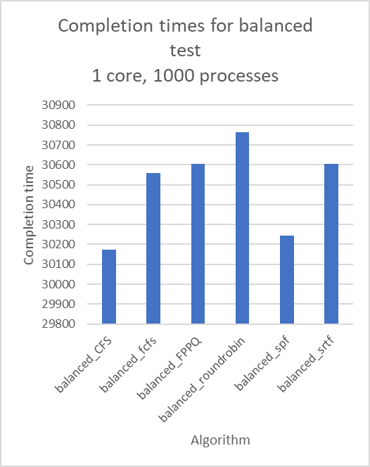
Figure 4: Algorithm comparison, 1000 processes, 1 core

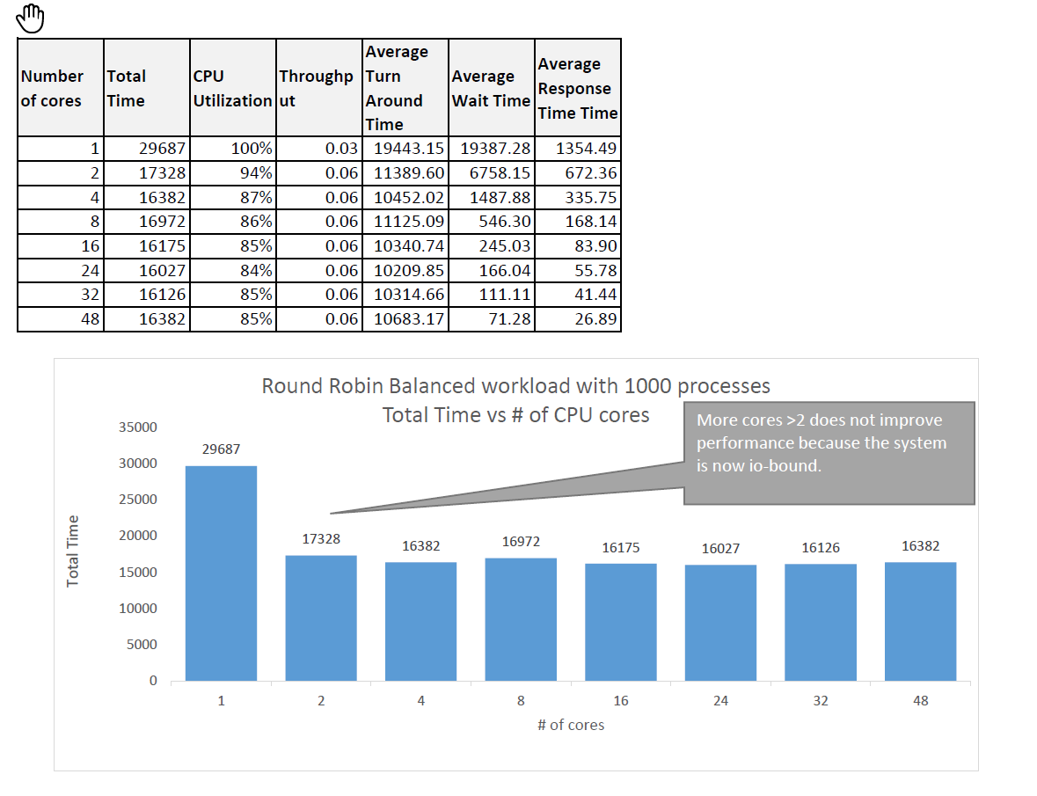
Table 3 and Figure 5: Round Robin Balanced Workload, 1000 processes, total time vs. cores

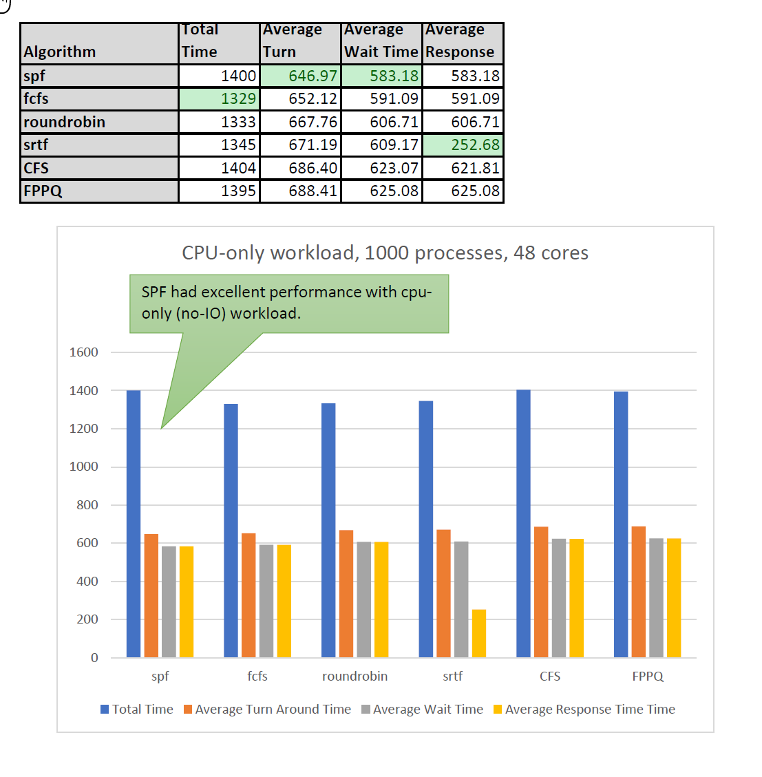
Table 4 and Figure 6: Performance

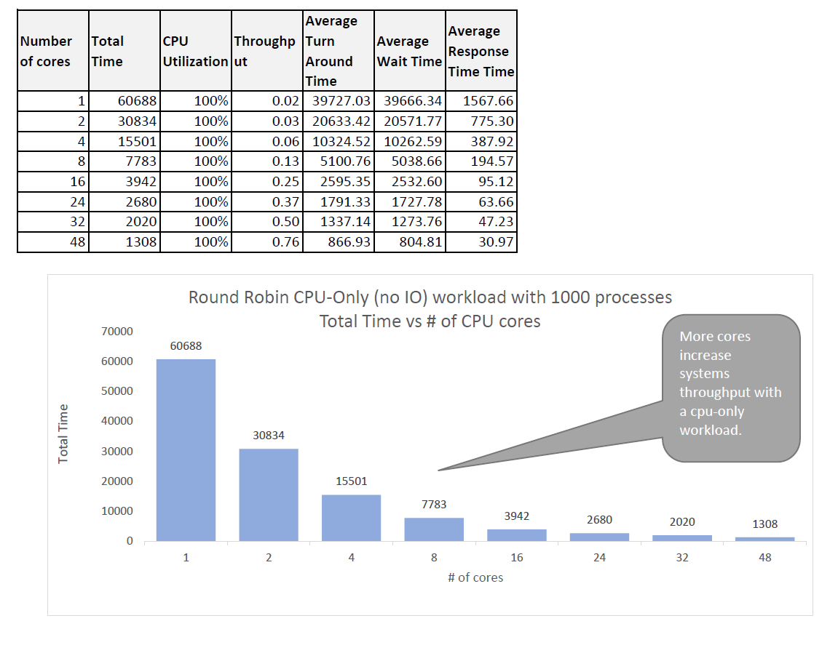
Table 5 and Figure 7: Round Robin, CPU-only, core count vs. performance, 1000 processes

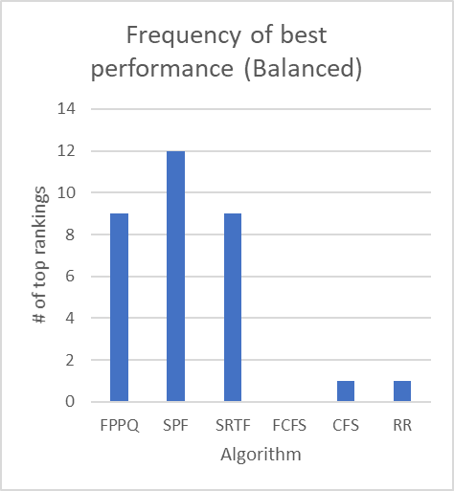
Figure 8: number of times an algorithm was ranked the best for each combination of core count and process size for balanced load

Overall Findings & Insights from the Results:
of the more interesting findings and results from our data and graphs that we realized is that:
- We noticed that in cases where we had more cores than processes the extra cores made little difference because the net effect is that each process gets a dedicated core.
- In addition, since this simulation is written with one slot available for IO, increasing the number of cores creates a situation in which the IO becomes the bottleneck. So, having more cores will impact your response time but not necessarily your overall turn around time for processes
- SJF and SRTF still give the best theoretical wait times, but FPPQ is surprisingly competitive on some tests with fewer cores.

From table 2 and figure 4 we can see that CFS beats the other algorithms in terms of completion time. From table 3 and figure 5, we can see that RR’s total time doesn’t change much once we have more than 2 cores because the system becomes io-bound. In table 4 and figure 6, we show that for 48 cores, the performance between the algorithms stays roughly the same, but with a significant decrease in SRTF’s average response time, potentially due to newly added processes having a lower-valued remaining CPU burst and thus beating out the process currently on the CPU. In table 5 and figure 7, we show that cpu-bound processes benefit the most from using multiple cores. Figure 8 was derived by performing a balanced test, finding the algorithms with the best wait time, and finding the frequency with which a particular algorithm is listed as the best. This shows that SPF is the best in this regard, followed by both SRTF and FPPQ.

Summary:
Overall, the project shows that a priori determination of the performance of various scheduling algorithms is difficult without knowledge of the distribution of the types of processes and without knowledge of the parameterization used for each algorithm, if applicable. In effect, the search space is huge and more investigation could be done in terms of finding optimal parameterizations for a given workload. It was interesting to see how quickly performance improvements diminish as more cores were made available to the algorithm.

Retrospective:

We learned how to work collaboratively as teammates. Working together as a team on this project was enjoyable. We were able to collaborate tightly and leverage each other’s strengths

We learned the importance of various scheduling algorithms on the systems performance and how the algorithms performed with varying number of processes, workloads, and number of cpu cores.

We also learned the importance of other system factors like IO which was a bottleneck in many of our simulations. We learned how the type of application (io-heavy or cpu-heavy) can greatly impact the operating systems performance.

We learned that while FCFS was a very easy to implement algorithm it’s performance was poor. We also learned that sometimes fairly simple preemptive algorithms like Round Robin can have solid performance when compared to more complex scheduling algorithms.

Things we would do next time:
- Create more test suites with more statistical rigor for the monte carlo process generation
- Model more scheduling algorithms like BFS [3]
- Make the machines more extensible.

Acknowledgment
We would like to acknowledge our professor, Amr Elkady, for his dedication to teaching our class this summer.
We would also like to acknowledge our colleagues in the class for their help in making the class enjoyable.

References

- Tanenbaum, Andrew S. “Scheduling” in Modern Operating
Systems, 4th ed.,New Jersey: Prentice Hall, 2015, pp.150-159
- M. T. Jones, “Inside the Linux 2.6 Completely Fair Scheduler,”
IBM Cognitive advantage reports, 15-Dec-2009. [Online]. Available: https://www.ibm.com/developerworks/linux/library/l-completely-fair-scheduler/. [Accessed: 08-Sep-2018]
- T. Groves, J. Knockel, and E. Schulte, “BFS vs. CFS: Scheduler
Comparison,” taylorgroves.com, 11-Dec-2009. [Online]. Available: http://www.taylorgroves.com/mwiki/images/2/2c/Bfs-v-cfs_groves-knockel-schulte.pdf. [Accessed: 07-Sep-2018].

